1. Design a leaflet

Imagine that a high voltage substation is soon to be located near your school. Write a public information leaflet to warn everyone of the dangers. Your leaflet should include 3 sections:

- General information about the substation:
Why do we need it?
What it is
What function it performs

- General information about health and safety
Keeping safe

- First aid for treatment of an electric shock

Your leaflet should be attractive so that people want to pick it up and read it.
It should contain all the key points of information.

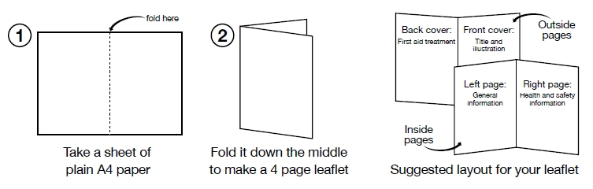

2. Design a poster

Design a poster encouraging people to take seriously the need to reduce their consumption of electricity. Include suggestions of ways to use the energy efficiently.

Search the Power up site for energy efficiency tips!

